

**Company Number 03311884**

**Charity Number 1062333**

**Invitation to Tender:**

**Café and Catering Operation at Kath Locke Centre, Manchester M15 5DD**

**Introduction**

The Kath Locke Centre has been at the heart of Hulme and Moss Side for 28 years. Built by the health authority it was given to a local social enterprise (Big Life) to manage in 1997. It houses several health and wellbeing services and activities. It is currently undergoing a major refurbishment, which will create a new Café opening into the recently renovated garden.

Alongside the café, the ground floor will also comprise a large function room and a smaller multipurpose room.

We are now seeking the right partner to lease the Café and provide a catering service to functions in the Centre. It is important to us that we appoint a ‘*partner*’ not just someone to run the café. The café will be the heart of the Centre, and we are looking for a provider who will work with us (and other organisations based in the Centre) to make it a destination which is welcoming and open to all.

**A destination**

Kath Locke was a local community activist who campaigned for change and was instrumental in establishing community groups and organisations such as the Moss Side Peoples Centre and the Abasindi Collective.

Many of us in the community, are fed up that the only thing people know about the area is the bad stuff. So, with funding from the Heritage Lottery, we have co-created an exhibition of local activism in Hulme and Moss Side, which will be housed in the new Café seating area. It will provide a vibrant backdrop to the café and attract people to visit and participate in heritage events.

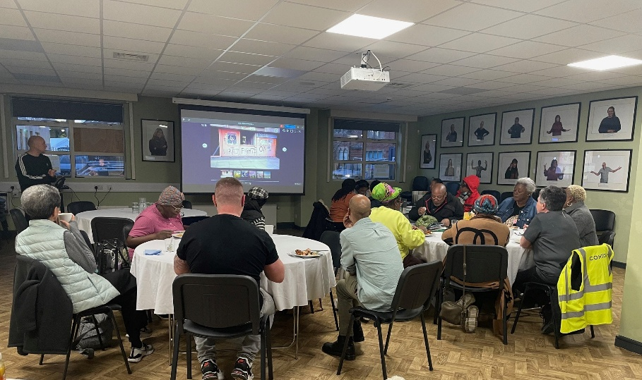



**The Opportunity**

The café will provide high-quality food and drinks that reflects the diversity of the local community. The Café seating area will accommodate 40 covers, with additional outside space.

The successful operator will also have the opportunity to be one of our approved caterers for events in our on-site function suite and may use the suite for their own events by agreement.

**Key Requirements**

We require the provider to:

* Operate during the Centres core hours (8am-6pm Monday to Friday), but we believe there is the opportunity for weekends and early evening opening and have designed the Café to be operated independently of the Centre.
* Offer culturally appropriate and diverse menus, with healthy options for all dietary needs (vegan, gluten-free, etc.)
* Provide catering services for events, with agreed pricing and profit-sharing.

**Financial Terms and Conditions**

The Centre has a fully fitted kitchen and has a storage area. The provider will be responsible for supplying their own coffee machine, crockery, cutlery, utensils, and specialist equipment.

The provider will be responsible for equipment maintenance and complying with Health and Safety and PAT testing requirements for equipment they have purchased.

The seating area will be furnished.

Cleaning will be provided by the Centre, but clearing and cleaning during the opening hours will be the responsibility of the provider.

An initial lease of two years, with intention to extend if successful. Payment is due quarterly in advance.

Reduced rent for six months start-up (September 2025 to March 2026) - £6,000

Full Year (April 2026 to March 2027) - £18,000. Negotiation of rent post March 2027 will be included in lease extension negotiation.

**The space**

**Employment and Compliance**

We strongly encourage submissions from employers who are Living Wage accredited employers or committed to paying staff at or above the Real living wage.

Full compliance with Pre-Qualification Questionnaire – see attached.

**Expectations of Service**

* Reliable operation within agreed hours
* Provision of breakfast, snacks and meals throughout opening hours.
* Consistent quality of food and service
* High standards of cleanliness and presentation
* Strong customer service skills
* Community engagement and responsiveness to customer feedback
* Enthusiasm to participate in events essential
* Interest in managing own events desirable.

**Tender Submission Requirements**

**Applicants must submit:**

1. **Pre-Qualification Questionnaire – see attached**
2. **Introduction (500 words max)**

* To your business – how long it has operated, track record etc
* Why you think your business is a good fit

1. **Qualities and Experience (500 words max)**

* Relevant experience operating cafés or catering services
* Proof of qualifications and relevant food hygiene and safety certificates
* Evidence of maintaining these standards in previous roles
* Three years of audited accounts

1. **Proposal for the Café (500 words max)**

* Vision for the café and how it will meet the needs of the local community
* Sample menus and pricing for both café service and event catering

1. **Key Suppliers (250 words max)**

* Details of suppliers for food, drink, and disposables

1. **Team structure (250 words max)**

* Overview of the team structure, management experience, and key staff members

1. **Customer Service and Skills (250 words max)**

* Plans for customer service training and standards
* Handling of customer feedback and complaints

1. **Environmental Sustainability (250 words max)**

* Plans for reducing food waste
* Use of sustainable packaging and environmentally friendly practices

1. **Current Provisions of a Similar Nature (250 words max)**

* Details of any other café or catering services currently operated

1. **Contingency Plans**

* Plans for maintaining consistent service levels and cover for unexpected absences

**Timetable and Evaluation**

**Site Visits**

Potential bidders can arrange a visit to the site ahead of submitting a tender. If you would like to arrange a visit, please email: [Sharon.kelly@thebiglifegroup.com](mailto:Sharon.kelly@thebiglifegroup.com)

As this is a building site, all visits will need to be booked in advance. No speculative visits are possible.

**Proposals**

Proposals must be submitted by email to [Sharon.kelly@thebiglifegroup.com](mailto:Sharon.kelly@thebiglifegroup.com) by 5th May 2025.

**Assessment of tenders**

The Prequalification Questionnaire is a hurdle qualification and businesses that do not pass the PQQ will not be considered. If you do not have all the information required, please contact us so that we can advise whether this is acceptable.

A panel will assess qualifying tenders as follows:

* Business background and experience (20%)
* Food quality, creativity, and cultural appropriateness (20%)
* Environmental sustainability practices (15%)
* Community integration and social impact (15%)
* Financial viability and pricing (10%)
* Customer service plans and staff development (10%)
* Supplier relationships and quality (5%)
* Contingency and risk management plans (5%)

A shortlist of bidders will be invited to interview and provide tasting menus.

**Timeline**

* Tender issued: 7th April 2025
* Site visits and Q&A: April 2025
* Submission deadline: 5th May 2025
* Shortlist notification: 12th May 2025
* Interviews and food tasting: w/c 19th May 2025
* Operator appointed: w/c 26th May 2025
* Anticipated café opening: July 2025

**Submission**

Submit your completed tender application and supporting documents to: Sharon.kelly@thebiglifegroup.com

For questions, site visit requests, or further information, please contact: Sharon.kelly@thebiglifegroup.com

**We look forward to receiving your proposals and working together to make the Kath Locke Centre café a vibrant and valued community destination.**