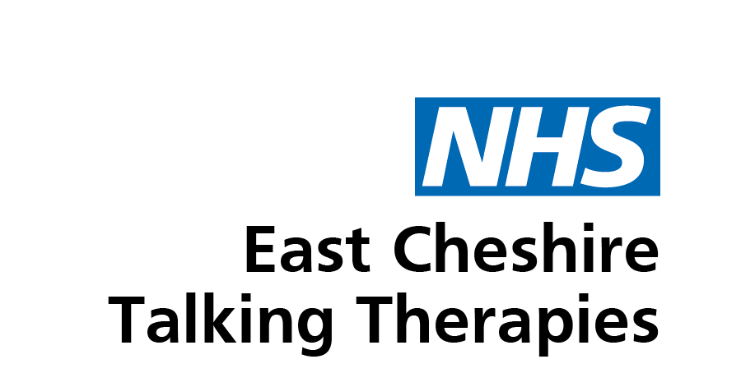

Talking Therapies Eastern Cheshire: Client Agreement
- I agree to access therapy in accordance with Talking Therapies missed appointments policy.
- If my GP changes during therapy, I will provide Talking Therapies with my new GP's name and contact details.
- I understand that if Talking Therapies staff members or volunteers feel that I could be a danger to myself or others, or that I may be in danger from harm from others, they may contact my GP, the emergency services, or other relevant professional. Furthermore, I understand that if Talking Therapies staff members of volunteers have any concerns relating to the safety of a child or vulnerable adult, they will be required to inform the relevant professional. Unless the circumstances are exceptional, I will always be informed prior to any action being taken.
- I understand that a report will be sent to my GP or referrer when I complete the therapy. The report generally contains scores from clinical measures, details of further treatment requirements, and details of change of circumstances in relation to education, employment or volunteering.
- I understand that I can make a comment, compliment, or complaint about my experience of the service by contacting Ella Simms at talking.therapies.ec@thebiglifegroup.com
- Talking Therapies has zero tolerance to aggressive and violent behaviour, such behaviour may result in the service being withdrawn.
- I agree to fill in several questionnaires before, during and on completion of therapy. The answers to the questionnaires may be published internally or externally, but this will be done anonymously (i.e., without my name or any other identifying information).
- I have received a copy of the Privacy Notice.
- I understand that email should only be used for non-urgent and non-confidential correspondence.
- I agree to respect the confidentiality of fellow clients.
- I agree to abide by the terms of this agreement.
Client's name:
Client's signature:
Worker's name and signature:
Date:

